Quantum Computing Functions (QCF) for Matlab

Charles Fox
Dept. of Engineering Science, University of Oxford, UK
charles@robots.ox.ac.uk

Quantum computing uses unitary operators acting on discrete state vectors. Matlab is a well known (classical) matrix computing environment, which makes it well suited for simulating quantum algorithms. The QCF library extends Matlab by adding functions to represent and visualize common quantum operations. This document presents a brief tutorial/overview of QCF, then shows how it can be used to simulate the well-known algorithms of Deutsch, Deutch-Jozsa, and Grover.

Basic notation

There are three basic quantum state notations that are frequently used in the literature: integer kets, binary kets, and vectors. For example, the following are all representations of the same state (in a 3-qubit space):

|3> |011> [0 0 0 1 0 0 0 0 ]^{T}

The simulator uses vectors as its primary internal representation, but provides functions to convert between notations:

phi = bin2vec(bin)
Converts a single binary string state representation to a state vector.

phi=dec2vec(dec,n)
Convert single decimal state representation to state vector.
n is number of qubits in the vector space.

str = pretty(psi, [bin])
Gives a pretty-printed ket string for a (possibly superposed) state vector psi.
By default the integer ket representation is used. The optional bin flag gives the binary version.

For example:

>> phi_1=bin2vec('011')

0
0
0
1
0
0
0
0

>> phi_2 = dec2vec(5, 3)

0
0
0
0
0
1
0
0

Note that our vector representation is capable of handling superposed states:

>> psi = 1/sqrt(2)*phi_1 + 1/sqrt(2)*phi_2

0
0
0
0.7071
0
0.7071
0
0

…and so are the pretty-print functions:

>> pretty(psi)

0.7071|011> + 0.7071|101>

>> pretty(psi, 1)

0.7071|3> + 0.7071|5>

Fourier transforms

The Quantum Fourier Transform (QFT) uses normalized basis functions (unlike the classical Discrete Fourier Transform) to represent a discrete state vector:

|x> = 1 Σ_{j=1:N-1} e^{-2πixj/N} |j>
√N

As the basis is orthonormal, the QFT projections can be computed by the unitary transform:

ω⁰ ω¹ ω² ω³
.
.
.
QFT = 1 ω¹ ω² ω³ ω⁴
N ω² ω³ ω⁴ ω⁵
ω³ ω⁴ ω⁵ ω⁶
… …

... where ω is the N^{th} root of unity, e^{2πi/N}.

The QCF library provides a qft function which creates QFT matrices for any N:

QFT = qft(d)
Creates QFT matrix with d rows and cols, where d=2^{N}.

Note that the QFT is both unitary and hermetian, so the matrix obtained from the qft function can be used to transform in both directions.

In the following example we create a QFT matrix for a 3-qubit system:

>> QFT = qft(2^3)

Columns 1 through 4

0.3536 0.3536 0.3536 0.3536
0.3536 0.2500 + 0.2500i 0.0000 + 0.3536i -0.2500 + 0.2500i
0.3536 0.0000 + 0.3536i -0.3536 + 0.0000i -0.0000 - 0.3536i
0.3536 -0.2500 + 0.2500i -0.0000 - 0.3536i 0.2500 + 0.2500i
0.3536 -0.3536 + 0.0000i 0.3536 - 0.0000i -0.3536 + 0.0000i
0.3536 -0.2500 - 0.2500i 0.0000 + 0.3536i 0.2500 - 0.2500i
0.3536 -0.0000 - 0.3536i -0.3536 + 0.0000i 0.0000 + 0.3536i
0.3536 0.2500 - 0.2500i -0.0000 - 0.3536i -0.2500 - 0.2500i

Columns 5 through 8

0.3536 0.3536 0.3536 0.3536
-0.3536 + 0.0000i -0.2500 - 0.2500i -0.0000 - 0.3536i 0.2500 - 0.2500i
0.3536 - 0.0000i 0.0000 + 0.3536i -0.3536 + 0.0000i -0.0000 - 0.3536i
-0.3536 + 0.0000i 0.2500 - 0.2500i 0.0000 + 0.3536i -0.2500 - 0.2500i
0.3536 - 0.0000i -0.3536 + 0.0000i 0.3536 - 0.0000i -0.3536 + 0.0000i
-0.3536 + 0.0000i 0.2500 + 0.2500i -0.0000 - 0.3536i -0.2500 + 0.2500i
0.3536 - 0.0000i -0.0000 - 0.3536i -0.3536 + 0.0000i 0.0000 + 0.3536i
-0.3536 + 0.0000i -0.2500 + 0.2500i 0.0000 + 0.3536i 0.2500 + 0.2500i

We now apply the QFT to the psi state from the earlier example:

>> pretty(psi, 1)

0.7071|3> + 0.7071|5>

>> QFT*psi

0.5000
-0.3536 + 0.0000i
0.0000
0.3536 - 0.0000i
-0.5000 + 0.0000i
0.3536 - 0.0000i
-0.0000
-0.3536 + 0.0000i

>> pretty(QFT*psi)

0.5|000> + -0.35355+1.3878e-016i|001> + 1.1102e-016|010> + 0.35355-4.7184e-016i|011> + -0.5+8.8817e-016i|100> + 0.35355-7.7716e-016i|101> + -3.3306e-016|110> + -0.35355+1.0825e-015i|111>

Our QCF library includes the function iplot for visualizing complex vectors. In the example below, we use iplot to look at the effect of the QFT on psi:

iplot(psi)
Display a 3D complex plane graph of the complex vector psi.
The elements of psi are shown as dark spikes and are connected together by a lighter line.

(You may need to rotate the graph in 3D to see the iplot structures)

>> iplot(psi)
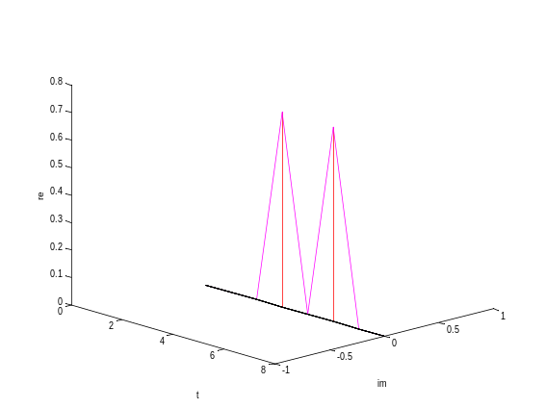

>> iplot(QFT*psi)
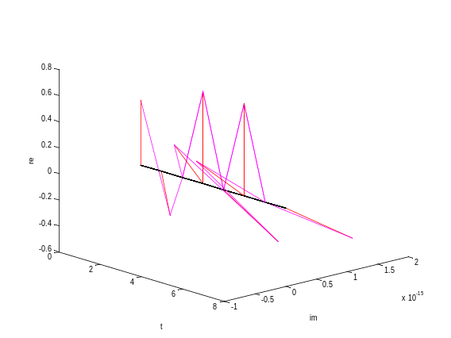

Unitary matrix representation of functions

It is often useful to use unitary matrices to represent functions. In this representation, the functions can be performed ‘in parallel’ on superpositions of inputs. We define the matrix U_{f} by:

U_{f} ( |x > ⊗ |0>^{(n)} ) = |x> ⊗ |f(x mod n)>

Where there are m bits in the input, x, and n bits in the output. Note that the action of U_{f} is to replace the zero vector with the value of f(x), whilst leaving the x in tact.

The QCF library function uf provides a quick way to construct such unitary matrices. To use it, we define an ordinary function f, and pass it as an argument to the uf constructor, along with specifications of n and m. This is necessary because Matlab functions operate on integers, not binary strings – so uf must be told how many bits to make space for.

U_f = uf(f,m,n)
Make unitary U_{f} from function f.
f must be of the form f(x,n) where x is a bitstring, and m and n is numbers of input and output bits.

Here we define a simple function, y, which returns the modulus of x+1. We then display a visualization of the unitary U_{y} which represents it:

function y = f(x,n)
y=mod(x+1, 2^n);

>> U_f = uf('f', 3, 2);
>> qimage(U_f)

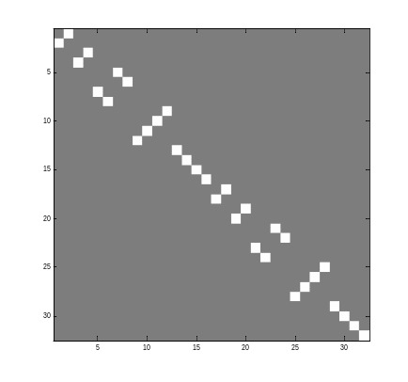
We now illustrate how the U_{f} matrix can be used. We form the state |psi> ⊗ |0>⁽²⁾ using the kron function for the tensor product. Applying U_{f} to the result simultaneously computes the superposed results of f for the two superposed states comprising |psi>.

>> pretty(psi)
0.7071|011> + 0.7071|101>

>> pretty(bin2vec('00'))
1|00>

>> pretty(kron(psi, bin2vec('00')))
0.7071|01100> + 0.7071|10100>

>> pretty(U_f * kron(psi, bin2vec('00')))
0.7071|01100> + 0.7071|10110>

Measurement

Measuring a state with respect to the standard basis causes it to collapse into one of its standard basis eigenstates, with an eigenstate’s probability given by the modulus of its squared amplitude. This non-deterministic process is simulated by the measure function:

phi = measure(psi)
Measure psi with respect to the standard basis.
(To perform other measurements, transform psi and phi to and from the required basis.)

Here we prepare and measure a state. Note that the second line assigns the new state to the same variable psi, as the old state. This syntax should be used to simulate the real-world fact that the original information in |psi> is irretrievably lost, and replaced by the collapsed |psi>:

>> psi = 1/sqrt(2)*phi_1 + 1/sqrt(2)*phi_2;
>> psi = measure(psi)

As |phi_1> and |phi_2> both have amplitude 1/sqrt(2), this measurement will result in the new |psi> collapsing to |phi_1> or |phi_2>, each with probability ½.

A more complicate form of measurement arises in quantum computing when we make a measurement on only some of the qubits in a register. This results in the measured qubits collapsing to definite binary values, but the unmeasured qubits may still be left in a superposition. For example:

>> psi = 0.5*(bin2vec('001001')+bin2vec(‘011010’)+bin2vec(‘101000’)+bin2vec(‘110100’));
>> pretty(psi)
0.5|001001> + 0.5|011010> + 0.5|101000> + 0.5|110100>

Suppose we measure qubits 2 and 5 (shown in bold above), leaving 1,3,4 and 6 untouched. If the observed values of the measured subspace are 11 or 10 then we have collapsed into the second or fourth (respectively) states in the list above. However if the values are (0,0) then we have collapsed into a superposition of the first and third states. The (1,1) and (1,0) outcomes each have a ¼ chance of occurring, whilst the (0,0) outcome has a ½ chance (due to it occurring in twice as many initial superposed states as the other outcomes).

Subspace measurement is simulated in QCF by the measure_subspace function:

[phi,obs] = measure_subspace(psi, M_str)
Make a measurement on a subspace M_str of qubits of register psi.

The input M_str is a character array (ie. a string) which specifies the qubits of the register psi to be measured and which are to be left alone. The letter ‘M’ denotes inclusion the measument and ‘X’ denotes exclusion. (The symbol ‘X’ is used in digital electronics for ‘don’t care’.) So to specify and perform the measurment from the above example, we can use:

>> M_str = 'XMXXMX';
>> [psi,obs] = measure_subspace(psi, M_str);

Then look at the results – in this (random) example the state has collapsed to the most likely result, the (0,0) case:

>> pretty(psi)
0.70711|001001> + 0.70711|101000>
>> obs
00

Deutsch’s algorithm

Deutsch’s was one of the first quantum algorithms to demonstrate an effect unobtainable by classical computation. Suppose we have four functions: c₀, c_{1,} b₀ and b₁ as given below:

Input: 0 1
c₀ 0 0
c₁ 1 1
b₀ 0 1
b₁ 1 0

The c functions are said to be ‘constant’ and the b functions are ‘balanced’. Given a black-box which computes U_{f}, where f is a function chosen from the above set, the task is to determine whether the function represented by U_{f} is constant or balanced. A classical machine would require two evaluations of the black-box. But Deutsch’s algorithm provides a way to do it in just one evaluation, on a quantum computer. The algorithm makes use the Hadamard transform, implemented in QCF by:

H = hadamard(n)
Returns the n-qubit Hadamard matrix.

We also use the measure function to collapse the final superposition into a single state:

phi = measure(psi)
Measure psi with respect to the standard basis.
(To perform other measurements, transform psi and phi to and from the required basis.)
psi (initial value) =
0
1
0
0

U_{f} =
0 1 0 0
1 0 0 0
0 0 1 0
0 0 0 1

H =
0.5000 0.5000 0.5000 0.5000
0.5000 -0.5000 0.5000 -0.5000
0.5000 0.5000 -0.5000 -0.5000
0.5000 -0.5000 -0.5000 0.5000

psi (just before measurement) =
0
0
0
-1.0000

psi (after measurement) =
0
0
0
1
The code below implements Deutsch for f=b₁. (It is included in QCF. Type deutsch to run it.) The panel on the right shows the variables during the execution. The results show the values of psi at the end of the algorithm, for the four black-box functions. Looking at the first qubit of the final states tells us whether the function is constant (0) or balanced (1).

function deutch
psi = bin2vec('01')
U_f = uf('f_b1', 1, 1)
H = hadamard(2)
psi = H*U_f*H*psi
psi = measure(psi)

function y = f_c0(x,n)
y=0;

function y = f_c1(x,n)
y=1;

function y = f_b0(x,n)
y=x;

function y = f_b1(x,n)
y=~x;

Results: function final psi
b₀ à |11>
b₁ à |11>
c₀ à |01>
c₁ à |01>

The Deutsch -Jozsa Promise Problem

This is a generalization of Deutsch’s algorithm to cases where the inputs to the constant/balanced functions have multiple bits. The functions output either 0 or 1, and are ‘promised’ to be either constant or balanced. Constant now means that the output is the same for any possible input. Balanced means that there are equal numbers of inputs which output 0 as output 1. As with the original Deutsch algorithm, the Deutsch-Jozsa problem can be solved with just one black box evaluation of the U_{f}.

Matlab/QCF code for Deutsch-Jozsa and some example test functions are shown below. (These are all included in QCF.) Note the deutsch_josza function has been defined so that a test function is passed in as an argument. The final, measured, psi state is interpreted by looking at the first N-1 qubits. If they are all zero then the function is constant. Otherwise, it is balanced. The images on the right are visualizations of two of the U_{f} matrices.

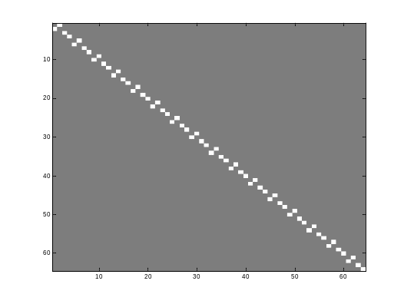
U_f for b_0

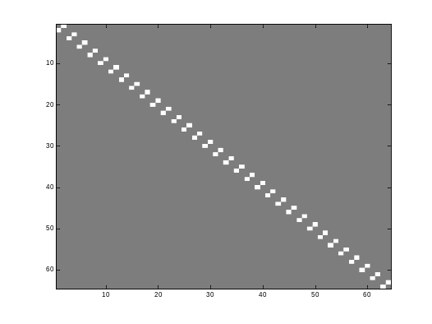
U_f for c_0
function deutsch_jozsa(f)
psi = bin2vec('000001');
U_f = uf(f, 5, 1);
H_6 = hadamard(6);
H_5 = hadamard(5);
I = identity(1);
psi = (kron(H_5, I))*U_f*H_6*psi;
psi = measure(psi);
pretty(psi)

%the test functions:

function y = dj_c0(x,n)
y=1;
function y = dj_c1(x,n)
y=0;
function y = dj_b0(x,n)
y=x;
function y = dj_b1(x,n)
y=~x;

To run the functions, type:

>> deutsch_jozsa('dj_c0')
1|000000>

>> deutsch_jozsa('dj_c1')
1|000001>

>> deutsch_jozsa('dj_b1')
1|000010>

>> deutsch_jozsa('dj_b0')
1|000011>

By looking a the first four qubits, we see that
So c₀ and c₁ are constant, b₀ and b₁ are balanced.

Grover’s Algorithm

Grover demonstrated that quantum computers can perform database search faster than their classical counterparts. In this simple example of Grover’s algorithm, we use a function haystack to represent the database. We are searching for a ‘needle in the haystack’, i.e. there is one element of the database that we require. The haystack function returns 1 if queried with the correct ‘needle’ element, and 0 for all the other elements. In this example, haystack is defined for a 5-qubit input, and returns 1 for element 8 (‘00100’).

Grover makes use of the fact that for any function f with a binary string input and a Boolean output, we can define a corresponding unitary matrix V_{f}, whose action on input strings |psi> is to invert them if and only if f(psi)=1. (Otherwise, it does nothing). The QCF library provides a function to create such matrices:

V_f = vf(f, n)
Build unitary f-conditional inverter for n bit input such that:
V_{f}|psi> = (-1)^{f(psi)}|psi>

Additionally, an ‘inversion about the average’ matrix, D, is used. The action of D on each element a_{i} of a state vector psi is to replace it with mean_{j}(a_{j})–a_{i}. Again, QCF has a function to build D for a specified state vector size.

D = ia(n)
Create ‘inversion about average’ matrix for n-qubit state vectors.
(black=-1; gray=0; white=1+)
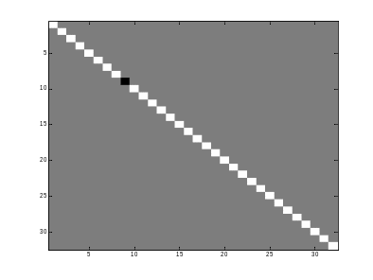
V_{haystack}
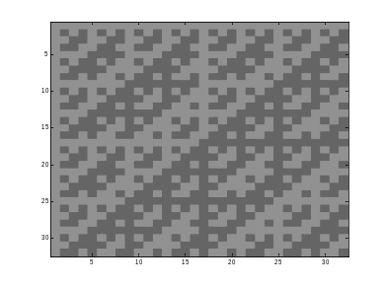
H
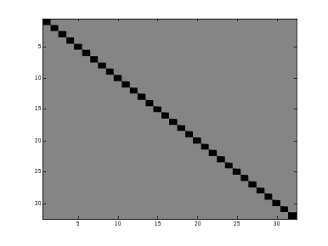
D
Grover’s algorithms works by iteratively applying V_{haystack}
and the inversion about the average operator to the current state.
Each iteration amplifies the probability of a measurement
collapsing the state to the correct ‘needle’ value.
Grover showed that performing a measurement after √(2^{n})*(π/4)
iterations is highly likely to give the correct result.

The code for Grover’s algorithm is given below.
On the right are visualizations of the matrices used.
The 3D graph on the next page shows the amplitudes of the
different ‘needle’ candidates. Note that the amplitude for 8 (the
correct needle value) reaches its peak at about √(2^{n})*(π/4)
iterations, as predicted.

To run the example, type grover.

function grover

n=5;

V_haystack = vf('haystack', n);
H = hadamard(n);
D = ia(n);

phi = bin2vec('00000');
phi = H*phi;

maxiter = (pi/4)*sqrt(2^n);

for i=1:10
phi=V_haystack*phi;
phi=D*phi;
end

phi=measure(phi);

Amplitudes for needle values during Grover’s algorithm iterations:

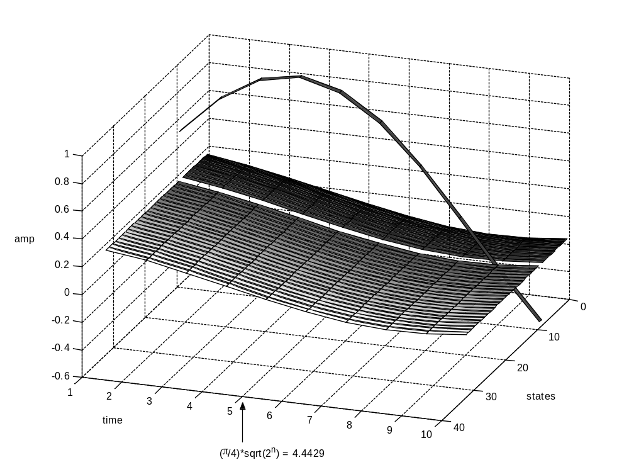

QCF API Summary

Type help qcf for complete list of functions. Most functions have additional help comments accessible by typing help <function name>. The most common functions are summarized here:

phi = bin2vec(bin)
Converts a single binary string state representation to a state vector.

phi=dec2vec(dec,n)
Convert single decimal state representation to state vector.
n is number of qubits in the vector space.

str = pretty(psi, [bin])
Gives a pretty-printed ket string for a (possibly superposed) state vector psi.
By default the integer ket representation is used. The optional bin flag gives the binary version.

QFT = qft(d)
Creates QFT matrix with d rows and cols, where d=2^{N}.

iplot(psi)
Display a 3D complex plane graph of the complex vector psi.

H = hadamard(n)
Returns the n-qubit Hadamard matrix.

phi = measure(psi)
Measure psi with respect to the standard basis.

[phi,obs] = measure_subspace(psi, M_str)
Make a measurement on a subspace M_str of qubits of register psi.

V_f = vf(f, n)
Build unitary f-conditional inverter for n bit input such that:
V_{f}|psi> = (-1)^{f(psi)}|psi>

D = ia(n)
Create ‘inversion about average’ matrix for n-qubit state vectors.

A note on using QCF for teaching and learning
QCF was written to aid the author’s study of basic quantum computation. I found I was spending too much time grinding through routine matrix algebra whilst doing exercises from Gruska and Neilsen&Chuang’s books. QCF allowed me to check quickly my solutions, as well as gain hands-on experience at ‘implementing’ the famous Deutsch and Grover algorithms. Although my implementations of these algorithms are included as demonstrations of what QCF can do, I think the student would benefit more from coding them with QCF rather than just watching my demonstrations. If you are a teacher considering using QCF to introduce students to quantum programming, I would suggest the following exercise as the basis of an afternoon’s practical programming class:

Remove the Deutsch, Deutsch-Josza and Grover functions from the students’ QCF installation (but leave the test functions, f, dj_b0, dj_b1, dj_c0, dj_c1). Supply the students with a copy of this documentation up to and including page 6 (Measurement). Get them to write their own implementations of the Deutsch, Deutsch-Josza and Grover algorithms, using QCF with Grusha or Neilsen&Chuang as a reference. I would also love to hear from anyone who implements Shor’s algorithm in Matlab/QCF, though this will require extra work in defining the necessary number-theoretic functions.

